Rack and pinion in a 73 -87 C10 GM Truck

By Dave Chapman and unnamed co-conspirators

The idea for this project came from various sources and discussions with some very knowledgeable Hot Rodders and truck builders, some over at webrodder.com and some over at 67-72chevytruck.com. The credit for the design, trail and error goes to the various Rodders on each board. Quite understandably no one laid out exactly what rack and hardware was needed and what the measurements were for mounting the rack and making the parts necessary to connect the steering arms to the rack, they weren’t writing a How-to article they were making it work with what they had and didn’t keep track of all the details and processes they went through. I’m guilty of that more times than I can remember. The point of this article is to put some numbers and pictures with the information gathered from all the various people and innovators that did the original design and research and add some of my own points and measurements. It is important to keep in mind that these are measurements on my truck that has a very modified front end, but the will be close enough to get you started.

I had just finished installing a 75 C10 IFS into my 58 3100 frame and needed a new steering box. On webrodder.com they were using pinto and mustang racks to replace the clunky GM boxes and getting great results. Over on the 67-72chevytrucks.com there was a lengthy discussion on using a mustang or thunderbird rack in 67 thru 87 GM pickups with a stock or modified GM suspension. Some of the guys on that board had done some great work on their trucks using these racks. It seemed pretty clear that that’s the way I wanted to go and it was going to be a good project. The kind of project that when it’s finished, you sit back and feel that grin break across your face and say, yeah I did that!

I decided to go with a power rack from an 86 Thunderbird without the performance suspension. The difference in the standard power rack and the performance suspension was the lock to lock turning on the rack. The performance suspension was 2.5 turns and standard was 3 turns lock to lock, big difference from my 4 ½ turns GM box.
The parts number I used was an A1-Cardone rebuilt 22-203A. There are 3 versions for this rack, 22-203F, 22-203T and the 22-203A. The F is Ford one piece mounting bushing, T is TRW with shorter pinion shaft housing but a longer shaft with a shaft housing that bolts on, and the A is Ford two piece mounting bushing and the pinion shaft housing does not bolt on it’s part of the casting. There are some other exterior differences and the dimensions are as follows:

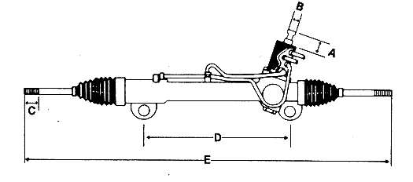
This picture is not of a TBird rack.

A1-Cardone Numbers

22-203F - A = 2”, B = ¾”, C = 3-7/8”, D = 15.5”, E = 45”, Mount holes = 2, 1 piece
Bushing

22-203T - A = 2.25”, B = ¾”, C = 3-7/8”, D = 15.5”, E = 45”, Mount holes = 2, piece bushing and a bolt on pinion shaft housing.

22-203A - A = 2”, B = ¾”, C = 3-7/8”, D = 15.5”, E = 45”, Mount holes = 2, 2 piece bushing.

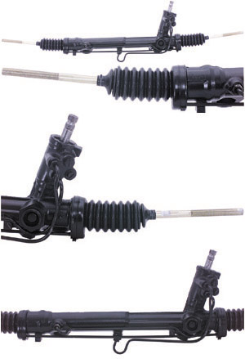

Part Numbers:

2 piece bushing number- AC-Delco Part # 45G24030.
The universal for the steering shaft is a ¾” 36 spline X ¾”DD – speedway motors

The stock inner tie rod end on the 22-203A rack was 11.55” long and it has a 15/16-20 inner thread and a 9/16”-18 end thread.

The outer Tie rod end I used was ES3004RL from a Thunderbird / Cougar 83-98, I re-threaded them to 9/16”-18.

You will need to make some tie rod end taper adapters. The tie rod stud taper on the spindle of the C10 is 2”/ft and the Tbird is 1.8”/ft.

Making this spacer is a pain in the butt. I think the way to go on this is was what fastbagged68 on the 67-72chevytrucks.com did, buy a piece of round stock and make an adjuster so you can use the stock outer tie rod end. It would be 11/16”-18 on one end and 9/16”-18 on the other. I choose to make the adapter.

One thing to watch for on the 22-203A and possibly the others is that the bushing mounts are not centered on the rack. When you check centering of the rack position take off the boots and measure from the housing ends to the frame and center it in the frame that way.

The rack measurements were 15.5” on the right side from the threaded end of the tie rod too the mounting bushing center. On the left it measured 14” from the threaded end of the tie rod end to the bushing center. Bushing center to bushing center is 15.5”. These measurements will change if you use a longer or shorter inner tie rod.

The center line of the rack is very close to 22.5” from each end of the tie rod. The right side mount is 6.75” from the rack center line and the left side mount is 8.75” from the center line of the rack.

Find the center line of the cross member and mark a line straight down the front of the member. Measure 6.75” to the right and 8.75” to the left and mark a line straight down the front of the member. This is where you will put your rack mounts. They may go higher or lower depending on your setup and if you have used a dropped member or not. I didn’t use a drop member and when I say right or left I mean as if you were in the drivers seat.

To recap:
You marked the center line on the rack and measured the offset of the mounts then you marked off the center of the cross member, measured the off set and placed the mount marks at 6.75” and 8.75” on the proper sides.

What remains is to determine how to actually mount the rack. You could use angle brackets with ¾” bolts, ¾” round stock welded to the member with some gussets for stability. You also have to determine if you need the mount to be rotated up or down for the steering shaft to clear and be accessible for the column shaft. What ever mounting you choose make sure it’s over built.

I went with a ¾” round bar tapped on one end to hold the bushings in. I rough guessed the length and tacked the ¾ rounds into place at 10 degrees downward in the front. I got the correct length for the ¾ bar stock and welded it in place. I checked to see if the rack was centered in the frame, it looked ok but I think I used my crooked eye because after I welded everything in solid it was off by a ½” to the right. Remember the off set bushings I told you about, it fixed that problem. Get them at speedway motors.

I sleeved the ¾ round with 1”OD ¾” ID DOM tube, cut the inside end to 10 degrees and cut it to the length of the stand out from the member I wanted and it left 2-1/8” from the sleeve to the tapped end just enough because that’s the inside width of the bushing. I welded the sleeve in place and welded support gussets to that.

Things to think about:
If you used a dropped cross member you may need to notch the frame rails to get the rack up high enough.
The tie rods need to be as close to a straight line with the rack as possible to eliminate bump steer at ride height.
The oil pan and or Harmonic balancer can be a clearance issue for the rack. You may have to move the engine up an inch or two.
If you center the mounts and not the rack itself you will lose some turn radius on one side or the other because the mounts are off set.
You may have to eliminate the bulge, or part of it, in the cross member to get the rack to center and back far enough to clear and line up. I did on mine but that may have been because it’s a C10 IFS on a 3100 frame.
You may or may not have to modify the headers to clear the steering shaft.
You will need multiple universal joints in your steering shaft with a hiem end to anchor it. Two joints does not need a heim end to stabilize that shaft 3 or more does need a hiem end and I think 3 would be the safe limit on the amount of u-joints in the shaft.

