Distributor Installation
- 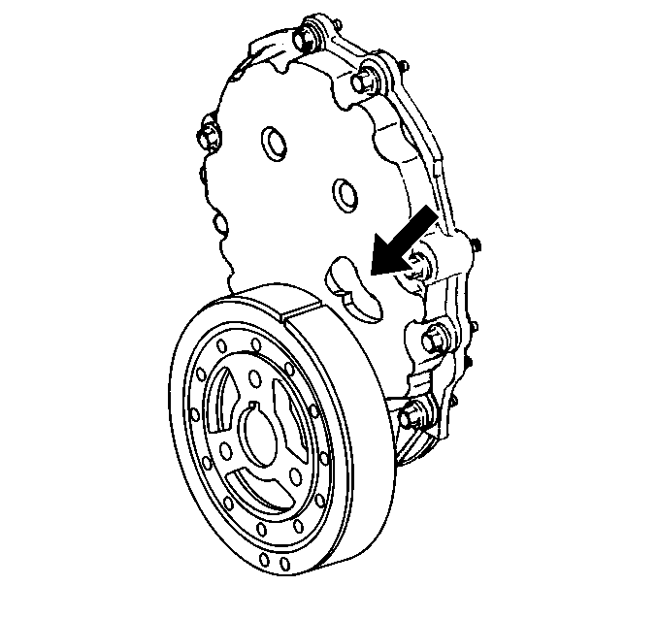

<LI type=1>Bring cylinder number one piston to Top Dead Center (TDC) of compression stroke.
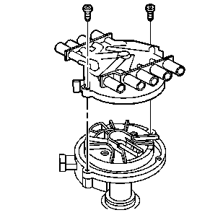
<LI type=1>Remove the distributor cap bolts and discard. <LI type=1>Remove the distributor cap.
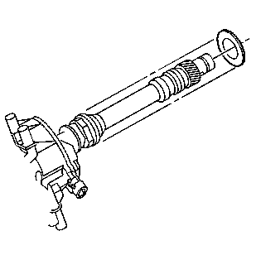
<LI type=1>Install a NEW distributor gasket onto the distributor.
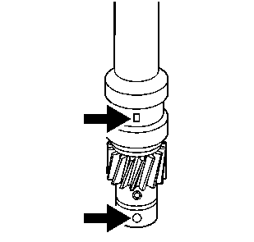
<LI type=1>Align the indent hole on the driven gear with the paint mark on the distributor housing. <LI type=1>Ensure that the distributor rotor segment points to the cap hold area.
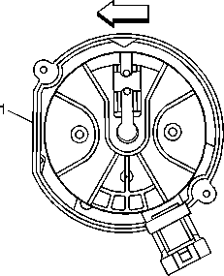
<LI type=1>Align the slotted tang in the oil pump driveshaft with the distributor driveshaft. Rotate the oil pump driveshaft with a screwdriver if necessary. <LI type=1>Align the flat (1) in the distributor housing toward the front of the engine. <LI type=1>Install the distributor and distributor clamp.
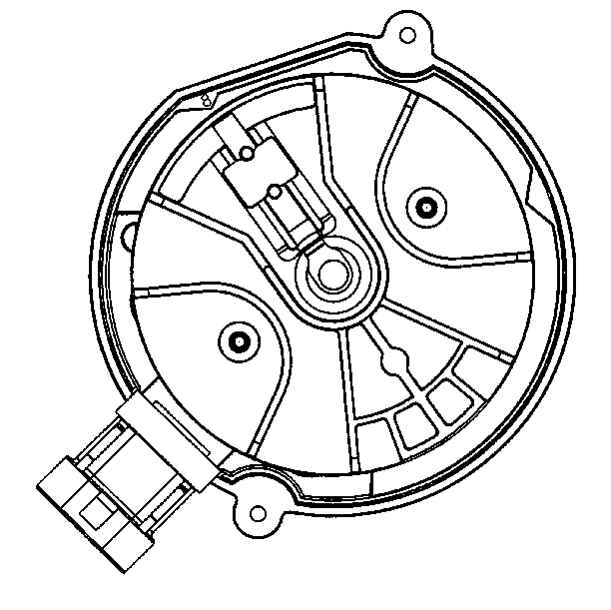
<LI type=1>Once the distributor is fully seated, align the distributor rotor segment with the number 8 pointer that is cast into the distributor base. <LI type=1>If the distributor rotor segment does not come within a few degrees of the number 8 pointer, the gear mesh between the distributor and camshaft may be off a tooth or more. Repeat the procedure in order to achieve proper alignment.
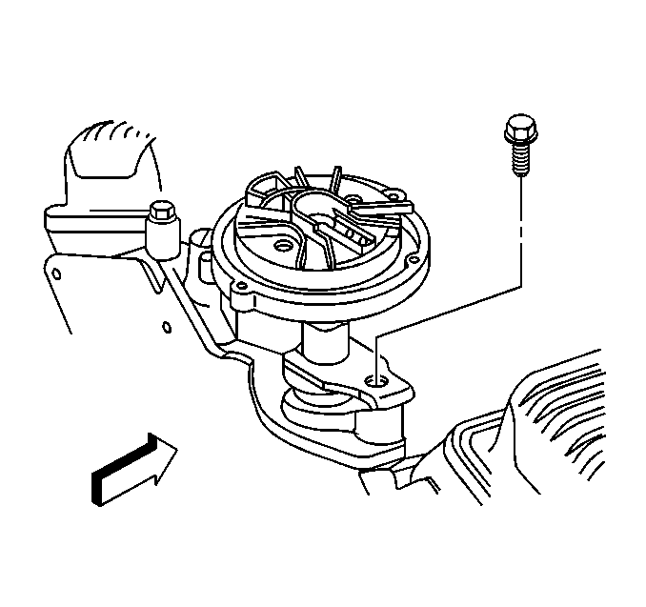
Notice: Use the correct fastener in the correct location. Replacement fasteners must be the correct part number for that application. Fasteners requiring replacement or fasteners requiring the use of thread locking compound or sealant are identified in the service procedure. Do not use paints, lubricants, or corrosion inhibitors on fasteners or fastener joint surfaces unless specified. These coatings affect fastener torque and joint clamping force and may damage the fastener. Use the correct tightening sequence and specifications when installing fasteners in order to avoid damage to parts and systems.
<LI type=1>Install the distributor clamp bolt.
Tighten
Tighten the distributor clamp bolt to 25 N·m (18 lb ft).
<LI type=1>Install the distributor cap onto the distributor. <LI type=1>Install the NEW distributor cap bolts. Do not overtighten the NEW distributor cap bolts.
Tighten
Tighten the distributor cap bolts to 2.4 N·m (21 lb in).
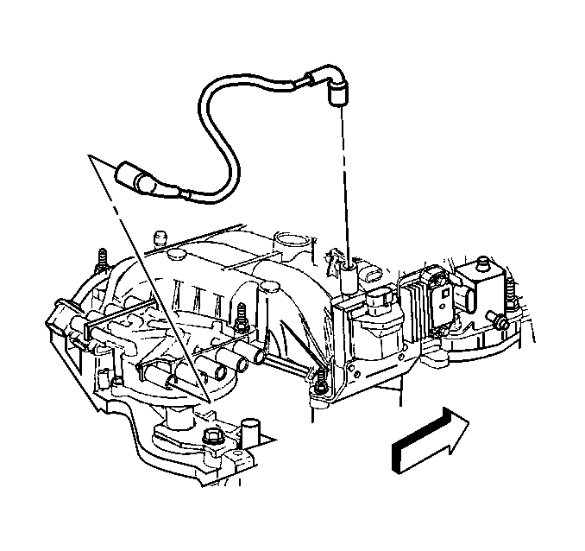
- Install the ignition coil wire harness.

